Use this page to track image usage or record descriptions. This document can be adapted for your needs and re-saved.

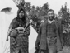 | The Stories and Histories of Alberta Image 1
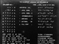 | The Stories and Histories of Alberta Image 2
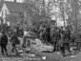 | The Stories and Histories of Alberta Image 3
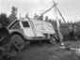 | The Stories and Histories of Alberta Image 4
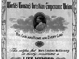 | The Stories and Histories of Alberta Image 5
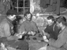 | The Stories and Histories of Alberta Image 6
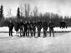 | The Stories and Histories of Alberta Image 7
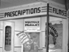 | The Stories and Histories of Alberta Image 8
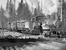 | The Stories and Histories of Alberta Image 9

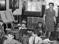 | The Stories and Histories of Alberta Image 10
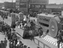 | The Stories and Histories of Alberta Image 11
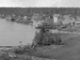 | The Stories and Histories of Alberta Image 12
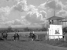 | The Stories and Histories of Alberta Image 13
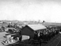 | The Stories and Histories of Alberta Image 14
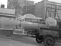 | The Stories and Histories of Alberta Image 15
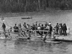 | The Stories and Histories of Alberta Image 16
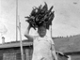 | The Stories and Histories of Alberta Image 17
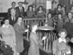 | The Stories and Histories of Alberta Image 18
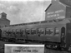 | The Stories and Histories of Alberta Image 19
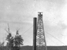 | The Stories and Histories of Alberta Image 20
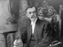 | The Stories and Histories of Alberta Image 21
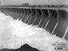 | The Stories and Histories of Alberta Image 22
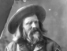 | The Stories and Histories of Alberta Image 23
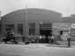 | The Stories and Histories of Alberta Image 24
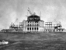 | The Stories and Histories of Alberta Image 25
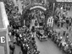 | The Stories and Histories of Alberta Image 26
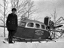 | The Stories and Histories of Alberta Image 27
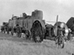 | The Stories and Histories of Alberta Image 28
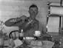 | The Stories and Histories of Alberta Image 29

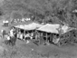 | The Stories and Histories of Alberta Image 30
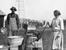 | The Stories and Histories of Alberta Image 31
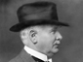 | The Stories and Histories of Alberta Image 32
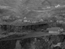 | The Stories and Histories of Alberta Image 33
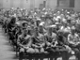 | The Stories and Histories of Alberta Image 34
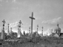 | The Stories and Histories of Alberta Image 35
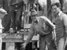 | The Stories and Histories of Alberta Image 36
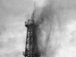 | The Stories and Histories of Alberta Image 37
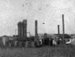 | The Stories and Histories of Alberta Image 38
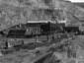 | The Stories and Histories of Alberta Image 39
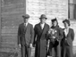 | The Stories and Histories of Alberta Image 40
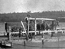 | The Stories and Histories of Alberta Image 41
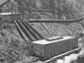 | The Stories and Histories of Alberta Image 42
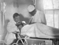 | The Stories and Histories of Alberta Image 43
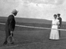 | The Stories and Histories of Alberta Image 44
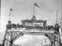 | The Stories and Histories of Alberta Image 45
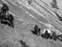 | The Stories and Histories of Alberta Image 46
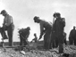 | The Stories and Histories of Alberta Image 47
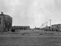 | The Stories and Histories of Alberta Image 48
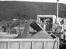 | The Stories and Histories of Alberta Image 49

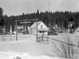 | The Stories and Histories of Alberta Image 50
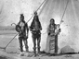 | The Stories and Histories of Alberta Image 51
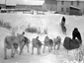 | The Stories and Histories of Alberta Image 52
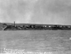 | The Stories and Histories of Alberta Image 53
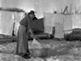 | The Stories and Histories of Alberta Image 54
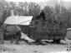 | The Stories and Histories of Alberta Image 55
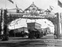 | The Stories and Histories of Alberta Image 56
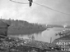 | The Stories and Histories of Alberta Image 57
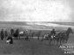 | The Stories and Histories of Alberta Image 58
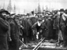 | The Stories and Histories of Alberta Image 59
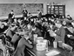 | The Stories and Histories of Alberta Image 60
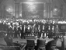 | The Stories and Histories of Alberta Image 61
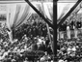 | The Stories and Histories of Alberta Image 62
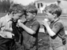 | The Stories and Histories of Alberta Image 63
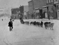 | The Stories and Histories of Alberta Image 64
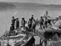 | The Stories and Histories of Alberta Image 65
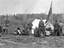 | The Stories and Histories of Alberta Image 66
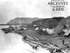 | The Stories and Histories of Alberta Image 67
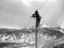 | The Stories and Histories of Alberta Image 68
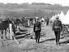 | The Stories and Histories of Alberta Image 69
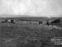 | The Stories and Histories of Alberta Image 70
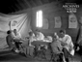 | The Stories and Histories of Alberta Image 71
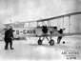 | The Stories and Histories of Alberta Image 72
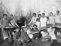 | The Stories and Histories of Alberta Image 73
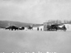 | The Stories and Histories of Alberta Image 74
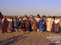 | The Stories and Histories of Alberta Image 75
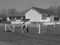 | The Stories and Histories of Alberta Image 76
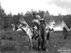 | The Stories and Histories of Alberta Image 77
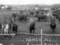 | The Stories and Histories of Alberta Image 78
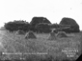 | The Stories and Histories of Alberta Image 79
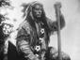 | The Stories and Histories of Alberta Image 80
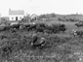 | The Stories and Histories of Alberta Image 81
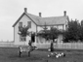 | The Stories and Histories of Alberta Image 82
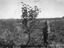 | The Stories and Histories of Alberta Image 83
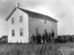 | The Stories and Histories of Alberta Image 84
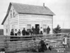 | The Stories and Histories of Alberta Image 85
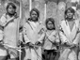 | The Stories and Histories of Alberta Image 86
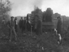 | The Stories and Histories of Alberta Image 87
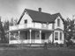 | The Stories and Histories of Alberta Image 88
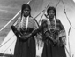 | The Stories and Histories of Alberta Image 89
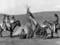 | The Stories and Histories of Alberta Image 90
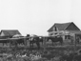 | The Stories and Histories of Alberta Image 91
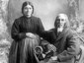 | The Stories and Histories of Alberta Image 92
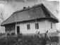 | The Stories and Histories of Alberta Image 93
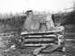 | The Stories and Histories of Alberta Image 94
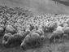 | The Stories and Histories of Alberta Image 95
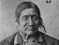 | The Stories and Histories of Alberta Image 96
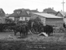 | The Stories and Histories of Alberta Image 97
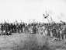 | The Stories and Histories of Alberta Image 98
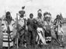 | The Stories and Histories of Alberta Image 99
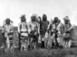 | The Stories and Histories of Alberta Image 100
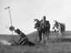 | The Stories and Histories of Alberta Image 101
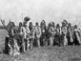 | The Stories and Histories of Alberta Image 102
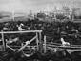 | The Stories and Histories of Alberta Image 103
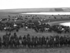 | The Stories and Histories of Alberta Image 104
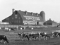 | The Stories and Histories of Alberta Image 105
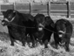 | The Stories and Histories of Alberta Image 106
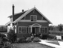 | The Stories and Histories of Alberta Image 107
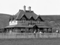 | The Stories and Histories of Alberta Image 108
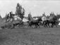 | The Stories and Histories of Alberta Image 109
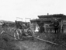 | The Stories and Histories of Alberta Image 110
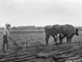 | The Stories and Histories of Alberta Image 111
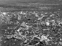 | The Stories and Histories of Alberta Image 112
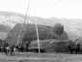 | The Stories and Histories of Alberta Image 113
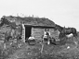 | The Stories and Histories of Alberta Image 114
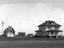 | The Stories and Histories of Alberta Image 115
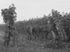 | The Stories and Histories of Alberta Image 116
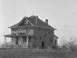 | The Stories and Histories of Alberta Image 117
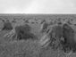 | The Stories and Histories of Alberta Image 118
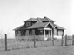 | The Stories and Histories of Alberta Image 119
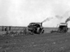 | The Stories and Histories of Alberta Image 120
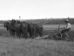 | The Stories and Histories of Alberta Image 121
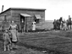 | The Stories and Histories of Alberta Image 122
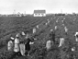 | The Stories and Histories of Alberta Image 123
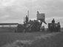 | The Stories and Histories of Alberta Image 124
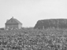 | The Stories and Histories of Alberta Image 125
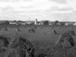 | The Stories and Histories of Alberta Image 126
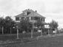 | The Stories and Histories of Alberta Image 127
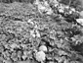 | The Stories and Histories of Alberta Image 128
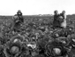 | The Stories and Histories of Alberta Image 129
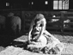 | The Stories and Histories of Alberta Image 130
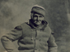 | The Stories and Histories of Alberta Image 131
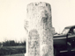 | The Stories and Histories of Alberta Image 132
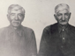 | The Stories and Histories of Alberta Image 133
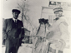 | The Stories and Histories of Alberta Image 134
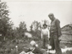 | The Stories and Histories of Alberta Image 135
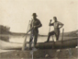 | The Stories and Histories of Alberta Image 136
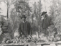 | The Stories and Histories of Alberta Image 137
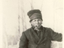 | The Stories and Histories of Alberta Image 138
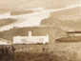 | The Stories and Histories of Alberta Image 139

