Use this page to track image usage or record descriptions. This document can be adapted for your needs and re-saved.

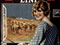 | Following Confederation Image 1
 | Following Confederation Image 2
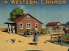 | Following Confederation Image 3
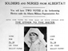 | Following Confederation Image 4
 | Following Confederation Image 5
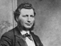 | Following Confederation Image 6
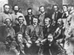 | Following Confederation Image 7
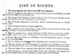 | Following Confederation Image 8
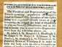 | Following Confederation Image 9

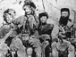 | Following Confederation Image 10
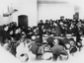 | Following Confederation Image 11
 | Following Confederation Image 12
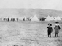 | Following Confederation Image 13
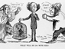 | Following Confederation Image 14
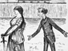 | Following Confederation Image 15
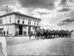 | Following Confederation Image 16
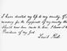 | Following Confederation Image 17
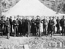 | Following Confederation Image 18
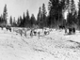 | Following Confederation Image 19
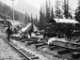 | Following Confederation Image 20
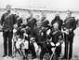 | Following Confederation Image 21
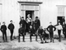 | Following Confederation Image 22
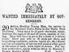 | Following Confederation Image 23
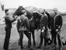 | Following Confederation Image 24
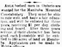 | Following Confederation Image 25
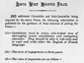 | Following Confederation Image 26
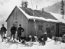 | Following Confederation Image 27
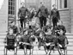 | Following Confederation Image 28
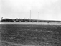 | Following Confederation Image 29

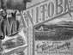 | Following Confederation Image 30
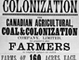 | Following Confederation Image 31
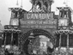 | Following Confederation Image 32
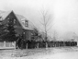 | Following Confederation Image 33
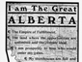 | Following Confederation Image 34
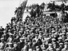 | Following Confederation Image 35
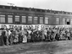 | Following Confederation Image 36
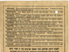 | Following Confederation Image 37
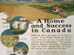 | Following Confederation Image 38
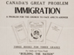 | Following Confederation Image 39
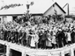 | Following Confederation Image 40
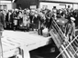 | Following Confederation Image 41
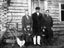 | Following Confederation Image 42
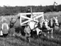 | Following Confederation Image 43
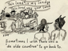 | Following Confederation Image 44
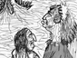 | Following Confederation Image 45
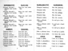 | Following Confederation Image 46
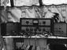 | Following Confederation Image 47
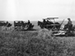 | Following Confederation Image 48
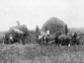 | Following Confederation Image 49

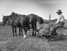 | Following Confederation Image 50
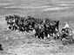 | Following Confederation Image 51
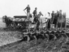 | Following Confederation Image 52
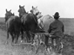 | Following Confederation Image 53
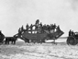 | Following Confederation Image 54
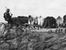 | Following Confederation Image 55
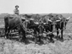 | Following Confederation Image 56
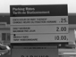 | Following Confederation Image 57
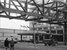 | Following Confederation Image 58
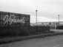 | Following Confederation Image 59
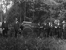 | Following Confederation Image 60
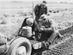 | Following Confederation Image 61
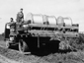 | Following Confederation Image 62
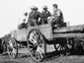 | Following Confederation Image 63
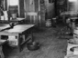 | Following Confederation Image 64
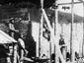 | Following Confederation Image 65
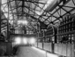 | Following Confederation Image 66
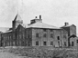 | Following Confederation Image 67
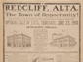 | Following Confederation Image 68
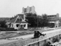 | Following Confederation Image 69
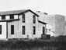 | Following Confederation Image 70
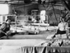 | Following Confederation Image 71
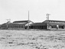 | Following Confederation Image 72
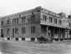 | Following Confederation Image 73
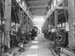 | Following Confederation Image 74
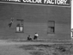 | Following Confederation Image 75
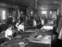 | Following Confederation Image 76
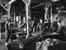 | Following Confederation Image 77
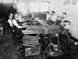 | Following Confederation Image 78
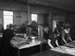 | Following Confederation Image 79
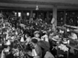 | Following Confederation Image 80
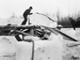 | Following Confederation Image 81
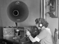 | Following Confederation Image 82
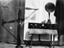 | Following Confederation Image 83
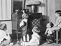 | Following Confederation Image 84
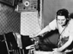 | Following Confederation Image 85
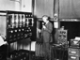 | Following Confederation Image 86
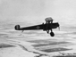 | Following Confederation Image 87
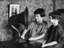 | Following Confederation Image 88
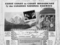 | Following Confederation Image 89
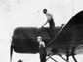 | Following Confederation Image 90
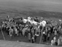 | Following Confederation Image 91
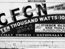 | Following Confederation Image 92
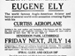 | Following Confederation Image 93
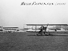 | Following Confederation Image 94
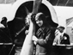 | Following Confederation Image 95
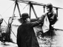 | Following Confederation Image 96
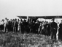 | Following Confederation Image 97
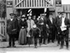 | Following Confederation Image 98
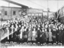 | Following Confederation Image 99
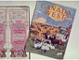 | Following Confederation Image 100
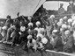 | Following Confederation Image 101
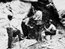 | Following Confederation Image 102
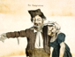 | Following Confederation Image 103
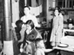 | Following Confederation Image 104
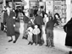 | Following Confederation Image 105
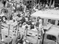 | Following Confederation Image 106
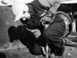 | Following Confederation Image 107
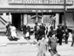 | Following Confederation Image 108
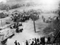 | Following Confederation Image 109
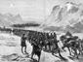 | Following Confederation Image 110
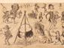 | Following Confederation Image 111
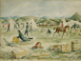 | Following Confederation Image 112
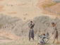 | Following Confederation Image 113
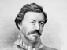 | Following Confederation Image 114
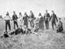 | Following Confederation Image 115
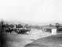 | Following Confederation Image 116
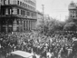 | Following Confederation Image 117
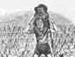 | Following Confederation Image 118
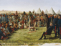 | Following Confederation Image 119
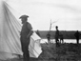 | Following Confederation Image 120
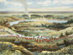 | Following Confederation Image 121
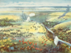 | Following Confederation Image 122
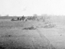 | Following Confederation Image 123
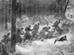 | Following Confederation Image 124
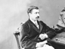 | Following Confederation Image 125
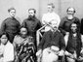 | Following Confederation Image 126
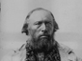 | Following Confederation Image 127
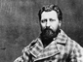 | Following Confederation Image 128
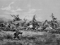 | Following Confederation Image 129
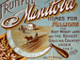 | Following Confederation Image 130
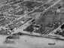 | Following Confederation Image 131
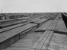 | Following Confederation Image 132
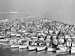 | Following Confederation Image 133
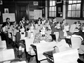 | Following Confederation Image 134
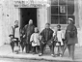 | Following Confederation Image 135
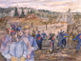 | Following Confederation Image 136
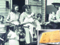 | Following Confederation Image 137
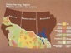 | Following Confederation Image 138
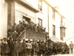 | Following Confederation Image 139
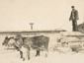 | Following Confederation Image 140

