Use this page to track image usage or record descriptions. This document can be adapted for your needs and re-saved.

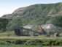 | West Canada Image 1
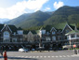 | West Canada Image 2
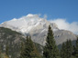 | West Canada Image 3
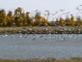 | West Canada Image 4
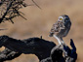 | West Canada Image 5
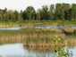 | West Canada Image 6
 | West Canada Image 7
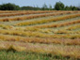 | West Canada Image 8
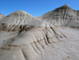 | West Canada Image 9

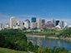 | West Canada Image 10
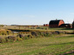 | West Canada Image 11
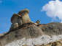 | West Canada Image 12
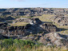 | West Canada Image 13
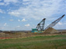 | West Canada Image 14
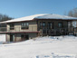 | West Canada Image 15
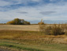 | West Canada Image 16
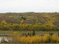 | West Canada Image 17
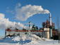 | West Canada Image 18
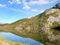 | West Canada Image 19
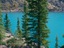 | West Canada Image 20
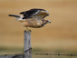 | West Canada Image 21
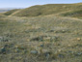 | West Canada Image 22
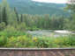 | West Canada Image 23
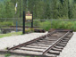 | West Canada Image 24
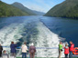 | West Canada Image 25
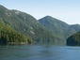 | West Canada Image 26
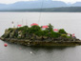 | West Canada Image 27
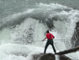 | West Canada Image 28
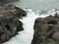 | West Canada Image 29

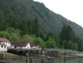 | West Canada Image 30
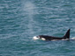 | West Canada Image 31
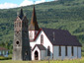 | West Canada Image 32
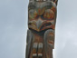 | West Canada Image 33
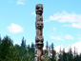 | West Canada Image 34
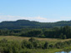 | West Canada Image 35
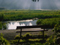 | West Canada Image 36
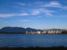 | West Canada Image 37
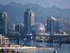 | West Canada Image 38
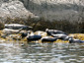 | West Canada Image 39
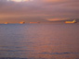 | West Canada Image 40
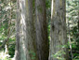 | West Canada Image 41
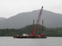 | West Canada Image 42
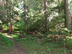 | West Canada Image 43
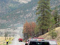 | West Canada Image 44
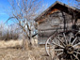 | West Canada Image 45
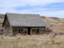 | West Canada Image 46
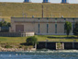 | West Canada Image 47
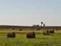 | West Canada Image 48
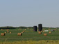 | West Canada Image 49

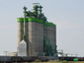 | West Canada Image 50
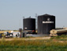 | West Canada Image 51

