Use this page to track Image usage or record descriptions. This document can be adapted for your needs and re-saved.
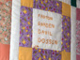 | Acadian Image 1
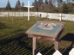 | Acadian Image 2
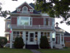 | Acadian Image 3
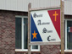 | Acadian Image 4
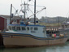 | Acadian Image 5
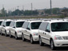 | Acadian Image 6  Halifax
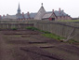 | Acadian Image 7  Louisbourg
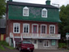 | Acadian Image 8
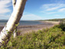 | Acadian Image 9

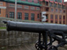 | Acadian Image 10  Louisbourg
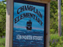 | Acadian Image 11  Champlain Elementary School
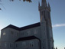 | Acadian Image 12
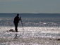 | Acadian Image 13
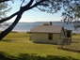 | Acadian Image 14
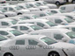 | Acadian Image 15  Halifax
 | Acadian Image 16  Evangeline Trail
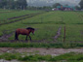 | Acadian Image 17
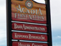 | Acadian Image 18
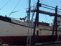 | Acadian Image 19
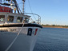 | Acadian Image 20  St. Mary's Bay
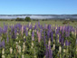 | Acadian Image 21
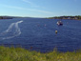 | Acadian Image 22  Annapolis Royal Harbour
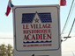 | Acadian Image 23  Historic Acadian Village
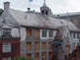 | Acadian Image 24  Historic Acadian Village
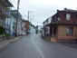 | Acadian Image 25  Historic Acadian Village
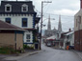 | Acadian Image 26  Historic Acadian Village
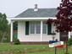 | Acadian Image 27
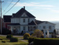 | Acadian Image 28  St. Mary's Bay
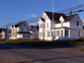 | Acadian Image 29  St. Mary's Bay

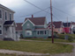 | Acadian Image 30
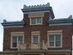 | Acadian Image 31
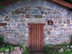 | Acadian Image 32
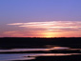 | Acadian Image 33
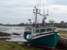 | Acadian Image 34
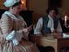 | Acadian Image 35  Historic Acadian Village
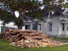 | Acadian Image 36
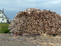 | Acadian Image 37
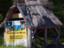 | Acadian Image 38
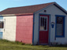 | Acadian Image 39
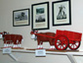 | Acadian Image 40
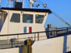 | Acadian Image 41
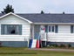 | Acadian Image 42
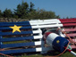 | Acadian Image 43
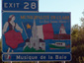 | Acadian Image 44
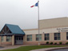 | Acadian Image 45
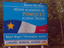 | Acadian Image 46
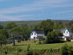 | Acadian Image 47
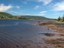 | Acadian Image 48
 | Acadian Image 49

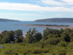 | Acadian Image 50
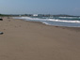 | Acadian Image 51
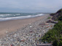 | Acadian Image 52
 | Acadian Image 53
 | Acadian Image 54
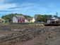 | Acadian Image 55
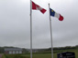 | Acadian Image 56
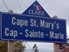 | Acadian Image 57
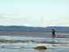 | Acadian Image 58
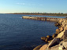 | Acadian Image 59
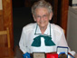 | Acadian Image 60
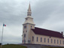 | Acadian Image 61
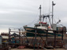 | Acadian Image 62
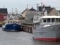 | Acadian Image 63
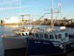 | Acadian Image 64
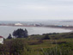 | Acadian Image 65
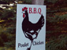 | Acadian Image 66
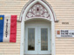 | Acadian Image 67
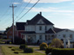 | Acadian Image 68
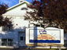 | Acadian Image 69

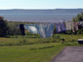 | Acadian Image 70
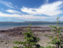 | Acadian Image 71
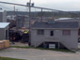 | Acadian Image 72
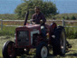 | Acadian Image 73
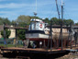 | Acadian Image 74
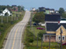 | Acadian Image 75
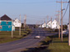 | Acadian Image 76
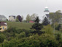 | Acadian Image 77
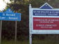 | Acadian Image 78

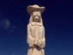 | Acadian Image 79
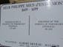 | Acadian Image 80
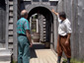 | Acadian Image 81
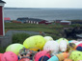 | Acadian Image 82
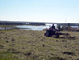 | Acadian Image 83
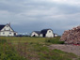 | Acadian Image 84

Image Collection photographs may be used freely in any non-profit educational context provided a credit to the source is included in your work. Any other use requires written permission from the copyright holder. Third-party Images are identified by a credit to the copyright holder.

