Use this page to track image usage or record descriptions. This document can be adapted for your needs and re-saved.
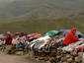 | Peru Image 1  Abra La Raya
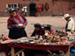 | Peru Image 2
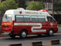 | Peru Image 3  Lima
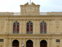 | Peru Image 4  Lima
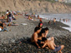 | Peru Image 5  Lima
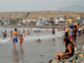 | Peru Image 6  Trujillo
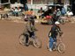 | Peru Image 7
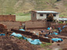 | Peru Image 8
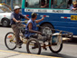 | Peru Image 9  Lima

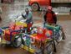 | Peru Image 10
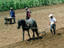 | Peru Image 11
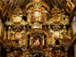 | Peru Image 12  Andahuaylillas
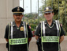 | Peru Image 13
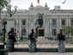 | Peru Image 14  Lima
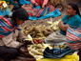 | Peru Image 15  Pisac
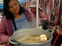 | Peru Image 16
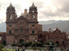 | Peru Image 17  Cusco
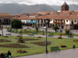 | Peru Image 18  Cusco
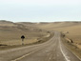 | Peru Image 19
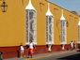 | Peru Image 20  Trujillo
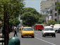 | Peru Image 21  Lima
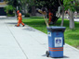 | Peru Image 22  Lima
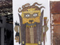 | Peru Image 23
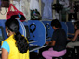 | Peru Image 24  Nazca
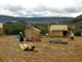 | Peru Image 25  Uros
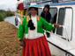 | Peru Image 26  Uros
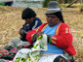 | Peru Image 27  Uros
 | Peru Image 28  Uros
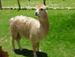 | Peru Image 29

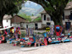 | Peru Image 30
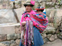 | Peru Image 31
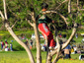 | Peru Image 32
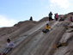 | Peru Image 33
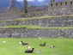 | Peru Image 34  Macchu Picchu
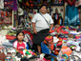 | Peru Image 35
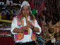 | Peru Image 36
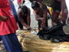 | Peru Image 37
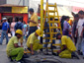 | Peru Image 38  Lima
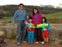 | Peru Image 39  Sacsayhuaman
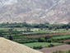 | Peru Image 40
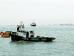 | Peru Image 41  Lima
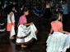 | Peru Image 42  Lima
 | Peru Image 43
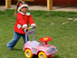 | Peru Image 44  Pukara
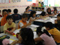 | Peru Image 45  Lima
 | Peru Image 46  Lima
 | Peru Image 47  Lima
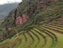 | Peru Image 48
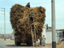 | Peru Image 49

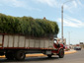 | Peru Image 50
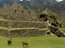 | Peru Image 51  Macchu Picchu
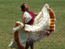 | Peru Image 52
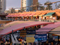 | Peru Image 53  Lima
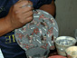 | Peru Image 54
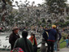 | Peru Image 55  Arequipa
 | Peru Image 56
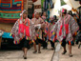 | Peru Image 57  Pisac
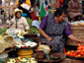 | Peru Image 58  Pisac
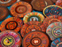 | Peru Image 59
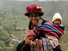 | Peru Image 60
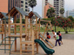 | Peru Image 61  Lima
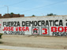 | Peru Image 62
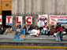 | Peru Image 63
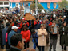 | Peru Image 64  Puno
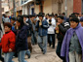 | Peru Image 65  Puno
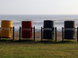 | Peru Image 66  Lima
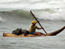 | Peru Image 67  Huanchaco
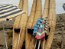 | Peru Image 68  Huanchaco
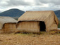 | Peru Image 69  Uros

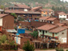 | Peru Image 70
 | Peru Image 71  Lima
 | Peru Image 72  Trujillo
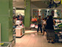 | Peru Image 73
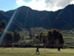 | Peru Image 74
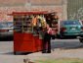 | Peru Image 75
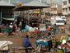 | Peru Image 76  Juliaca
 | Peru Image 77  Lima
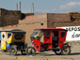 | Peru Image 78
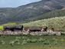 | Peru Image 79
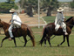 | Peru Image 80
 | Peru Image 81  Trujillo
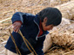 | Peru Image 82  Uros
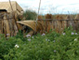 | Peru Image 83  Uros
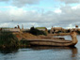 | Peru Image 84  Uros
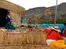 | Peru Image 85  Uros
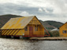 | Peru Image 86  Uros
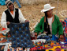 | Peru Image 87  Uros
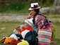 | Peru Image 88  Cusco

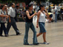 | Peru Image 89
Reproduced with permission from DiversityWorks Publishing.

Image Collection photographs may be used freely in any non-profit educational context provided a credit to the source is included in your work. Any other use requires written permission from the copyright holder. Third-party images are identified by a credit to the copyright holder.

