Use this page to track image usage or record descriptions. This document can be adapted for your needs and re-saved.
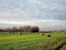 | Prairie Image 1
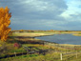 | Prairie Image 2
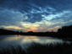 | Prairie Image 3
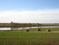 | Prairie Image 4
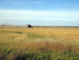 | Prairie Image 5
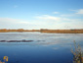 | Prairie Image 6
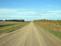 | Prairie Image 7
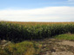 | Prairie Image 8
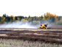 | Prairie Image 9

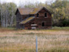 | Prairie Image 10
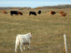 | Prairie Image 11
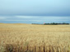 | Prairie Image 12
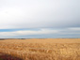 | Prairie Image 13
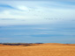 | Prairie Image 14
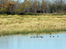 | Prairie Image 15
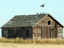 | Prairie Image 16
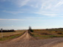 | Prairie Image 17
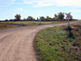 | Prairie Image 18
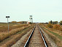 | Prairie Image 19
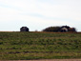 | Prairie Image 20
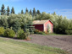 | Prairie Image 21
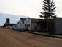 | Prairie Image 22  Pioneer Village, North Battleford
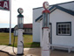 | Prairie Image 23  Pioneer Village, North Battleford
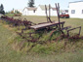 | Prairie Image 24  Pioneer Village, North Battleford
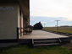 | Prairie Image 25  Pioneer Village, North Battleford
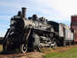 | Prairie Image 26  Pioneer Village, North Battleford
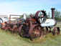 | Prairie Image 27  Pioneer Village, North Battleford
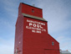 | Prairie Image 28
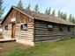 | Prairie Image 29

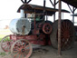 | Prairie Image 30  Pioneer Village, North Battleford
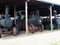 | Prairie Image 31  Pioneer Village, North Battleford
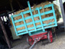 | Prairie Image 32  Pioneer Village, North Battleford
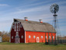 | Prairie Image 33
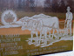 | Prairie Image 34  Pioneer Village, North Battleford
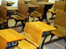 | Prairie Image 35  Pioneer Village, North Battleford
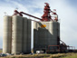 | Prairie Image 36
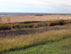 | Prairie Image 37
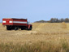 | Prairie Image 38
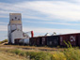 | Prairie Image 39
Reproduced with permission from Stone's Throw Software.

Image Collection photographs may be used freely in any non-profit educational context provided a credit to the source is included in your work. Any other use requires written permission from the copyright holder. Third-party images are identified by a credit to the copyright holder.

